# **Gen AI Interactive Learning Games Project Report by Visihishtaa B, Rishika N.**

## **Self Overview**

Hello all, ourself Visihishtaa B, Rishika N, **Artificial Intelligence and Data Science(AI&DS)** students from **Sri Sairam Institute of Technology,** embarked on an impactful **Intel internship**, contributing to the **Gen AI Interactive Learning Games.** This initiative focused on building a web-based tool that leverages AI to generate comic strips from user-provided text descriptions.

We had the **wonderful opportunity** to be selected as an **Intel Intern**, where we worked on the **Gen AI Interactive Learning Games** project. This internship allowed us to explore **AI-powered content generation**, To design a fun, interactive web-based AI game that combines basic puzzles, generative AI capabilities, and an evolving storyline where players act as agents solving challenges to unlock a futuristic time vault.

## **Project Overview**

"**AI Heist - The Time Vault**" is a retro-themed puzzle-adventure game where users solve challenges at each level. After each puzzle, their choice determines the direction of the story. The game uses open-source generative AI APIs to dynamically generate questions and evaluate user responses, adding an intelligent layer of adaptability and uniqueness.

## **Technical Architecture**

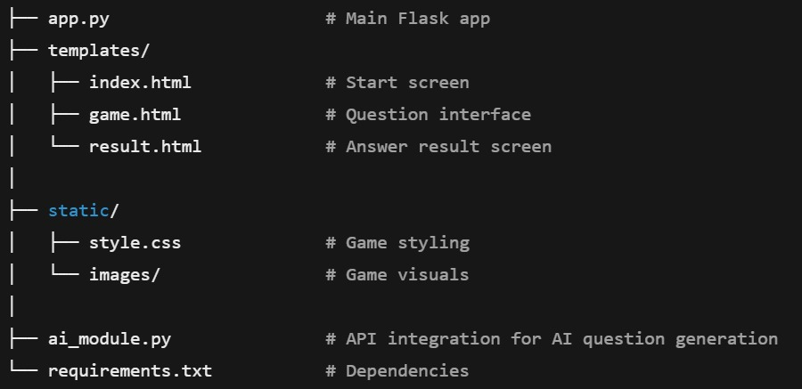

**1. User Interface (Frontend)**

* Developed using **Unity** (for mobile/PC) or **React.js/Flutter** (for web/mobile hybrid)
* Features:
  + Game environment
  + Interaction options (chat, voice, multiple choice)
  + Display of AI-generated content

**2. Game Engine**

* Controls game flow: levels, logic, UI transitions
* Integrates with AI to adapt scenarios or responses
* Supports animations, characters, sound

**3. Backend API Layer**

* Acts as the **middle layer** between UI and AI/Database
* Tech stack: **Node.js**, **Express.js**, or **Python Flask**
* Handles:
  + Requests for AI content
  + Player progress tracking
  + Authentication and user sessions

**4. Generative AI Module**

* Integrates with APIs like:
  + **OpenAI GPT-4 / Llama / Claude** for text generation
  + **DALL·E / StabilityAI** for image generation
  + **TTS/STT APIs** (Google, Azure, Coqui) for voice
* Responsibilities:
  + Generate custom quizzes
  + Create conversations with virtual characters
  + Provide real-time feedback or explanations

**5. Game Logic Engine**

* Manages game progression
* Decides difficulty levels based on performance
* Stores XP, achievements, badges

## **Technical Implementation Details**

**Interactive UI**

A simple and intuitive web interface developed using **Flask** with **HTML/CSS**, allowing smooth user interaction with the game.

**Level-based Gameplay**

Each level introduces a unique puzzle or question, gradually increasing in complexity to challenge the learner.

**Generative AI**

AI dynamically generates personalized questions and evaluates user responses in real-time, keeping the content fresh and adaptive.

**Storyline-based Choices**

Player decisions shape the direction of the story, creating a branching narrative for an engaging, role-playing experience.

**Pixel Art Design**

Retro-style **pixel art visuals** give the game a nostalgic, creative look while maintaining simplicity and performance.

**Conditional Navigation**

The player’s answers determine what content or "room" appears next, unlocking **new paths or plot twists** based on performance.

**HOME PAGE**

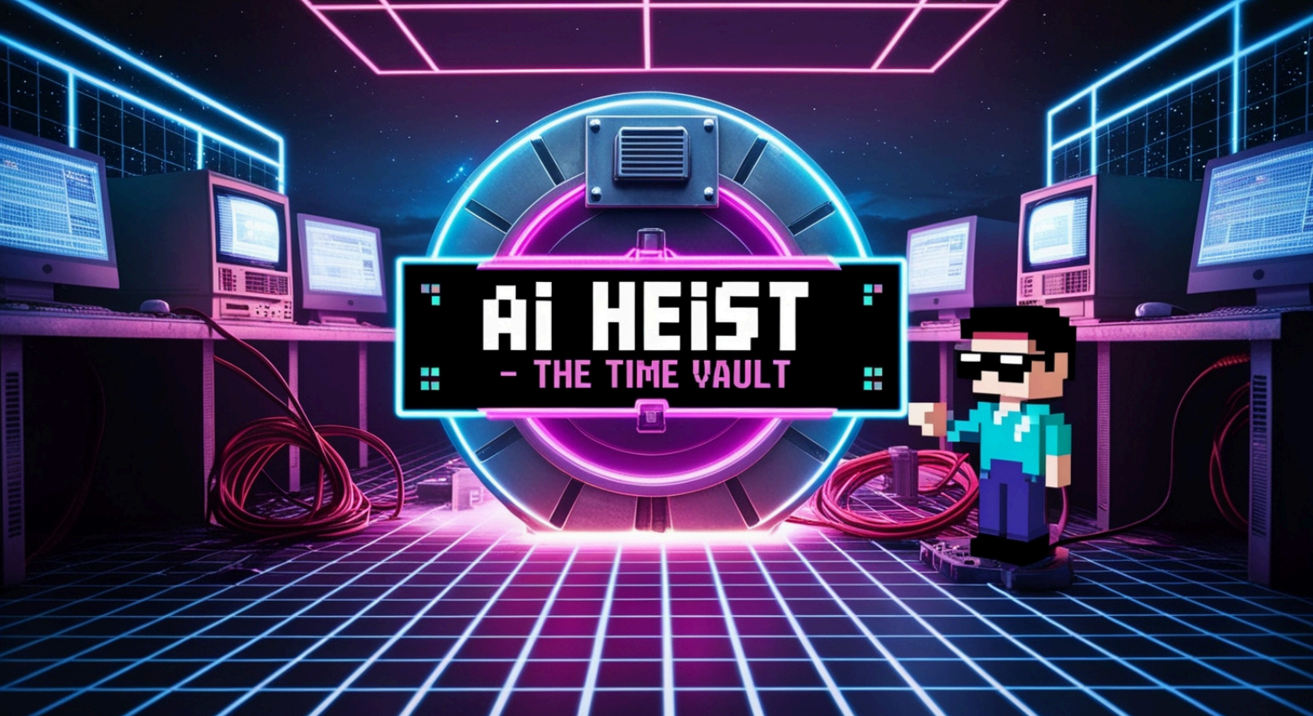

**OUTPUT VIDEO LINK:**

[**https://drive.google.com/file/d/1loL5p0iu0kJIT-bnqPbXo_5o8i9byDQa/view?usp=drive_link**](https://drive.google.com/file/d/1loL5p0iu0kJIT-bnqPbXo_5o8i9byDQa/view?usp=drive_link)

**GITHUB LINK**

[**https://github.com/visihishtaa/GEN-AI---INTEL/upload/main**](https://github.com/visihishtaa/GEN-AI---INTEL/upload/main)

## **Future Enhancement Opportunities**

1. Add characters and voiceovers.
2. Save progress using a user login system.
3. Display evolving story based on user decisions.
4. Multiplayer or competitive AI quiz mode.
5. Enhance with animations and music.

## **Conclusion**

“AI Heist – The Time Vault” is an AI-powered, puzzle-based educational game that combines interactive storytelling, retro pixel art, and generative AI to create an immersive learning experience. Players take on the role of a digital thief navigating through a mysterious vault, solving AI-generated puzzles and making storyline-based choices that influence the game’s progression. Each level adapts to the user’s performance, offering personalized challenges and dynamic outcomes. Built with Flask and HTML/CSS, the game serves as both a creative coding project and a fun entry into AI-enhanced interactive learning.